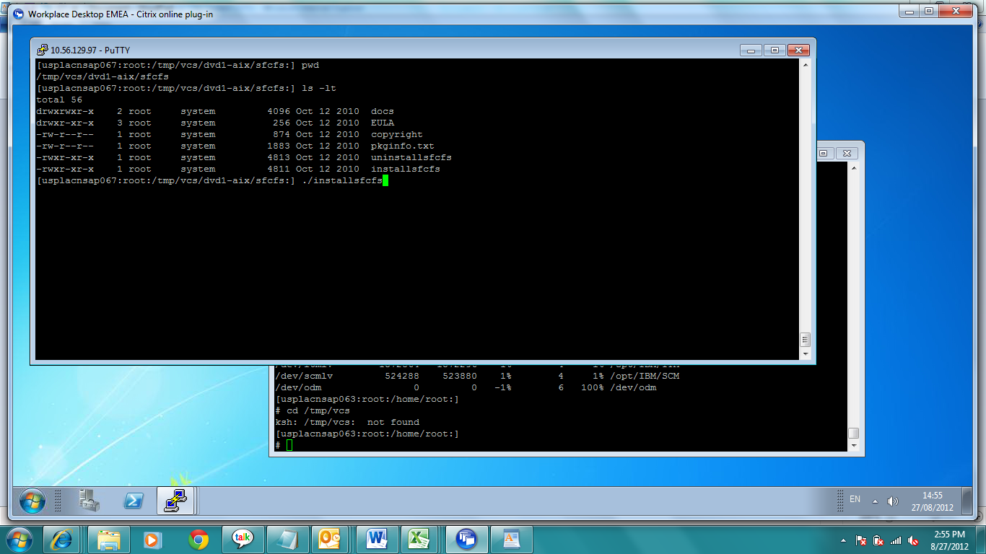
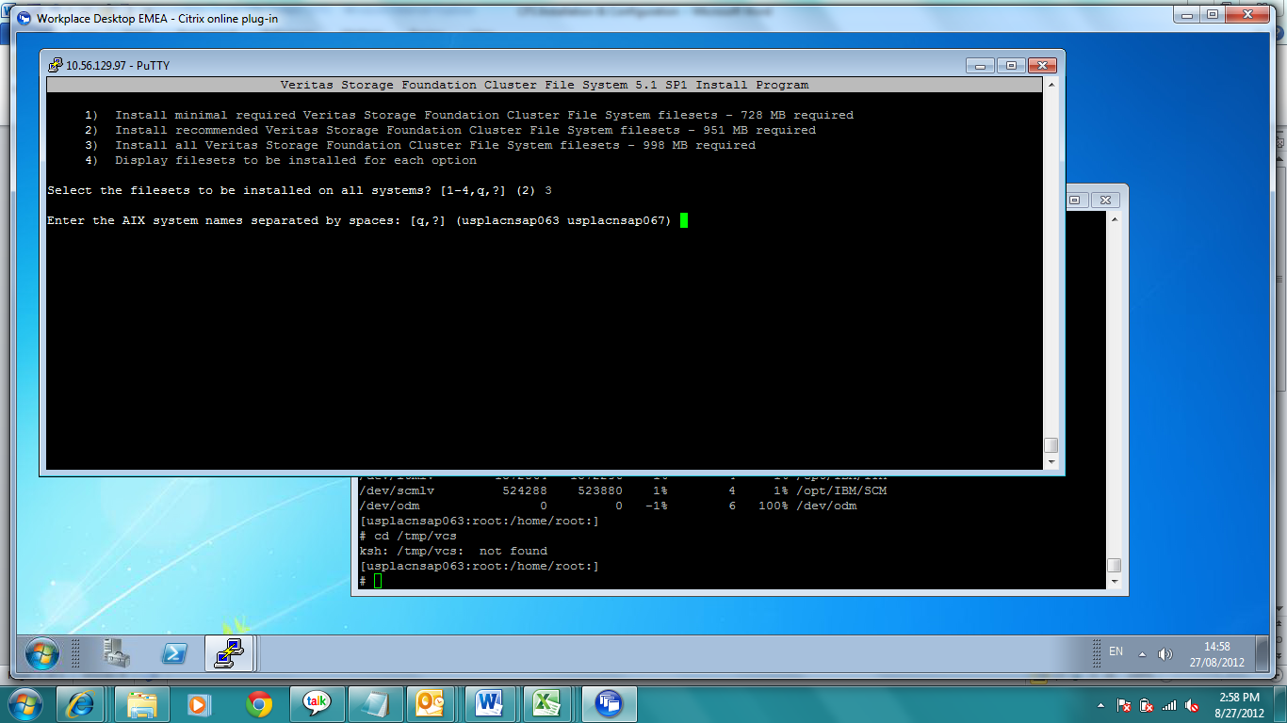
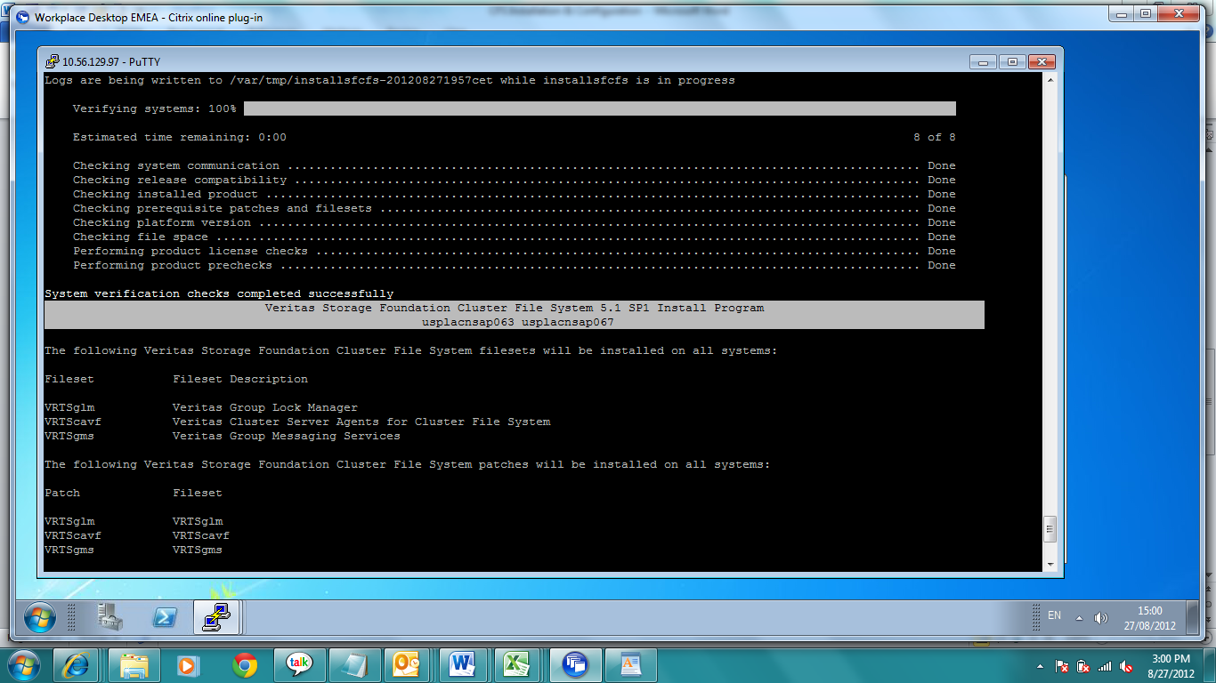
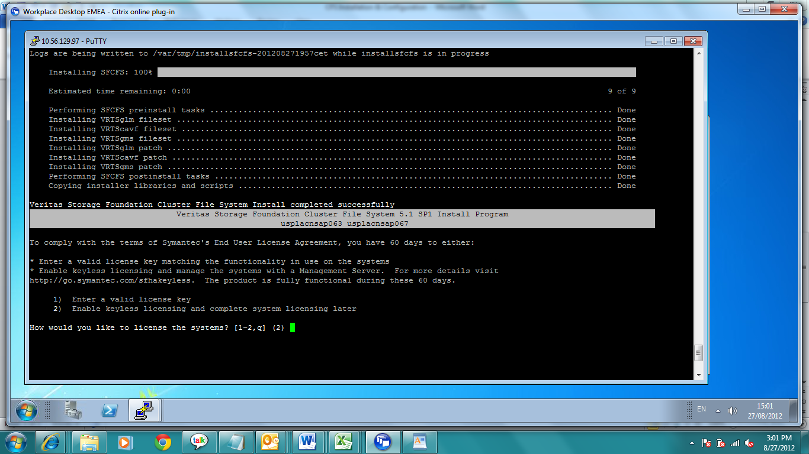
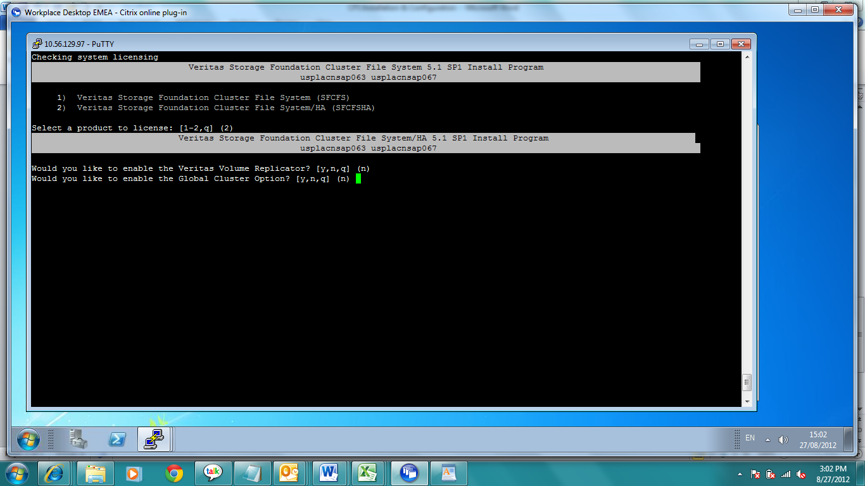
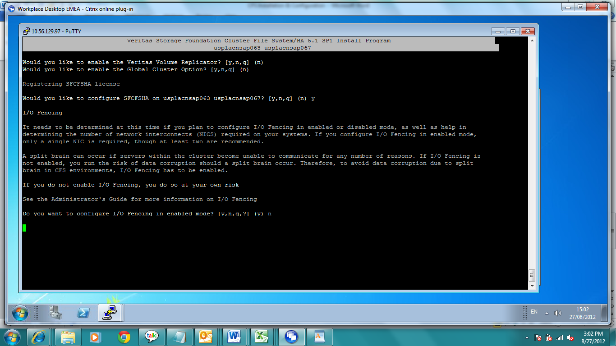
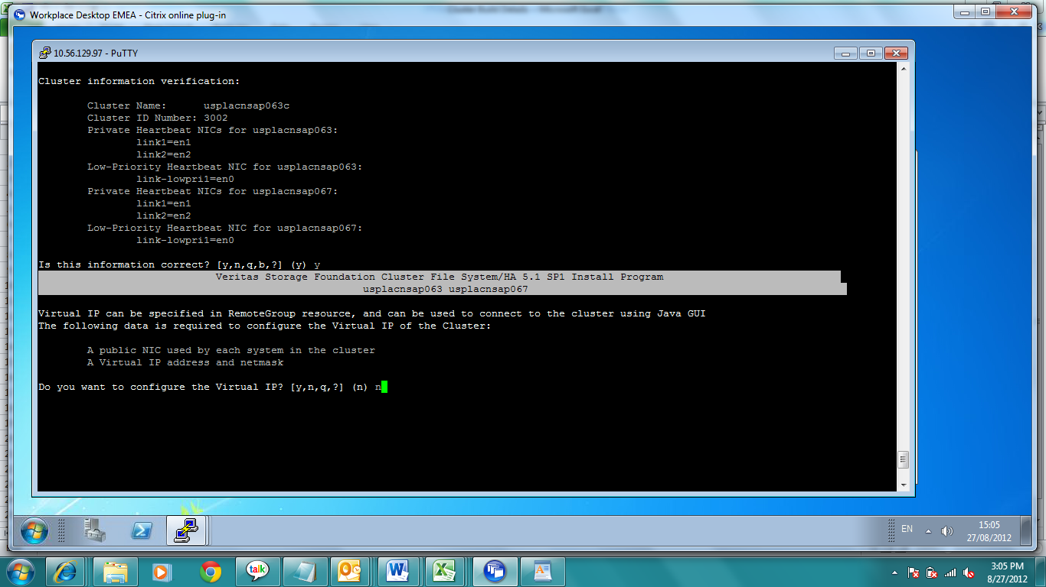
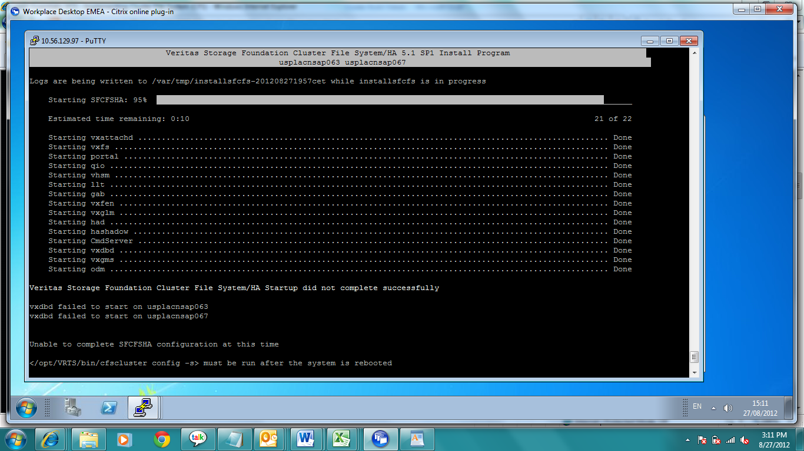
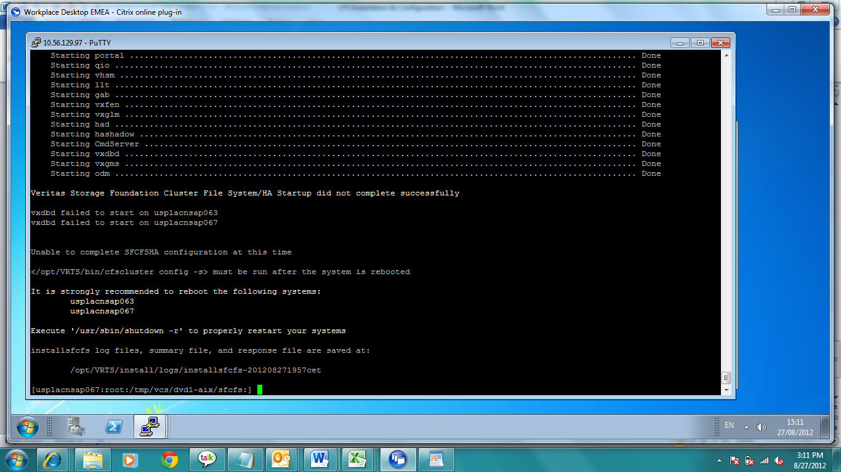
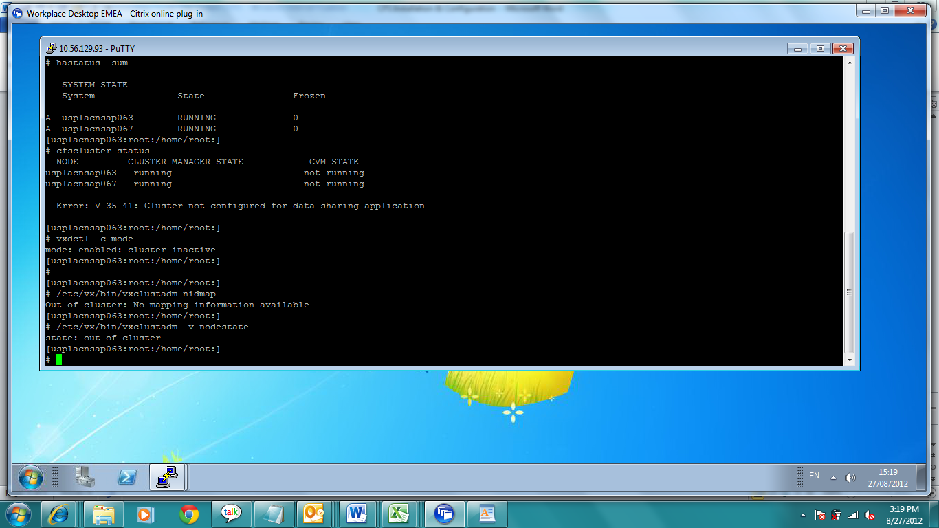
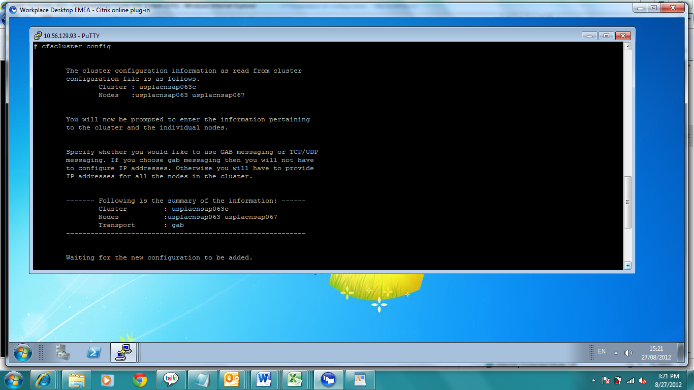
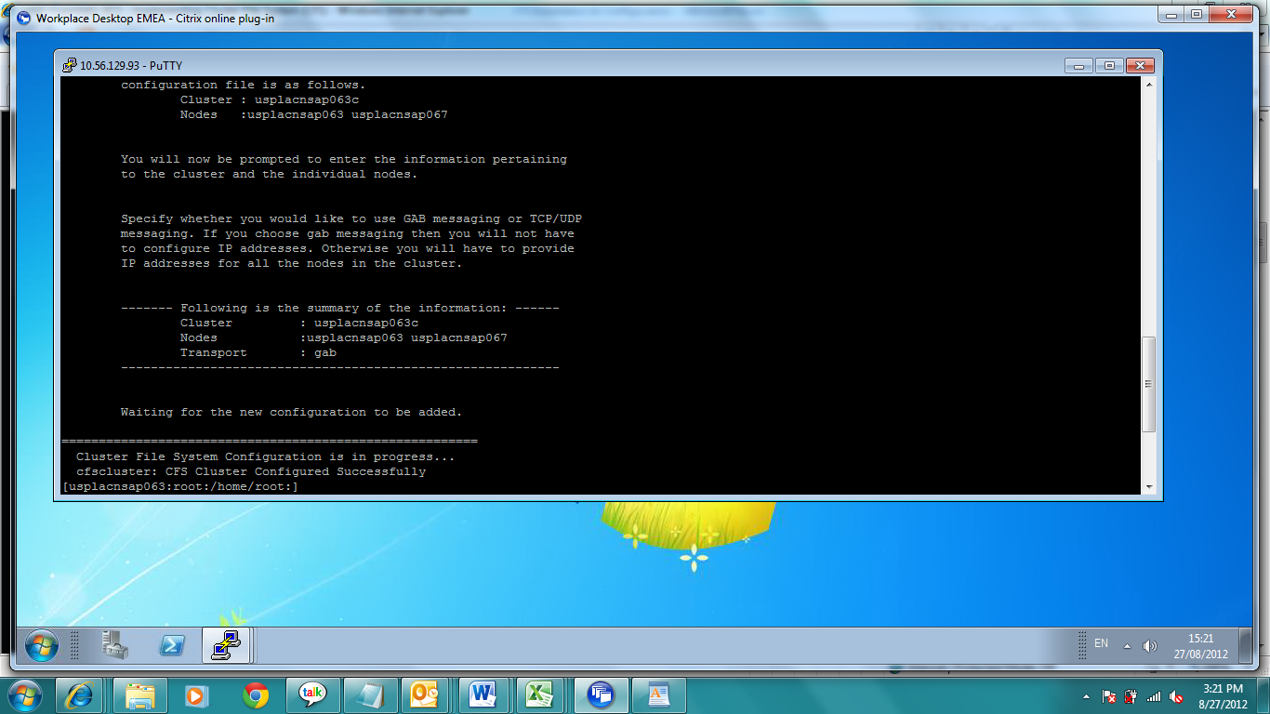
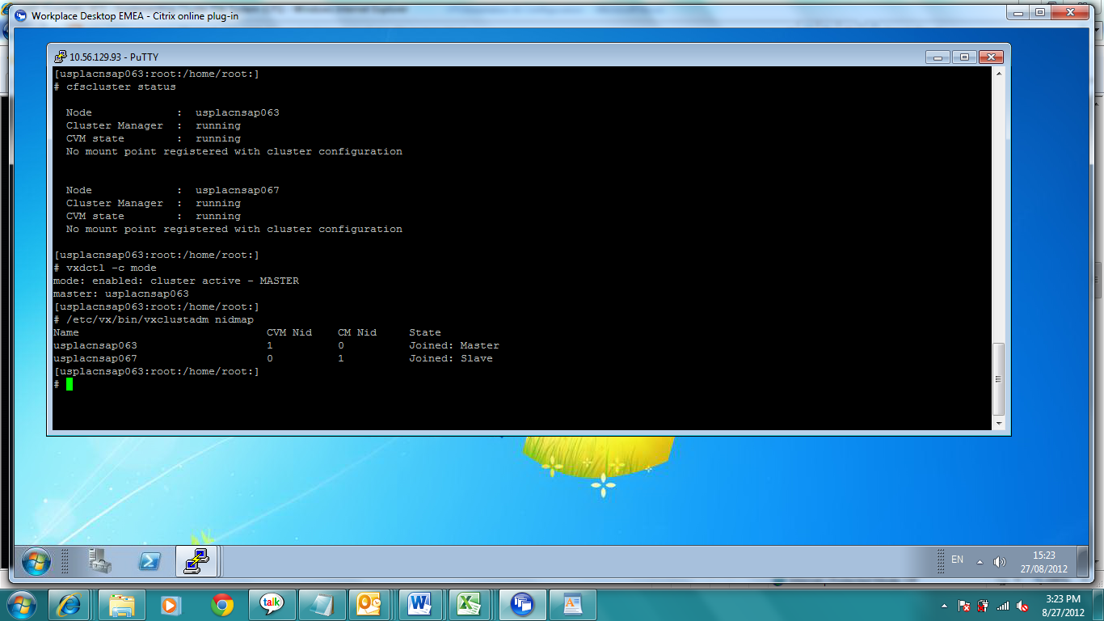
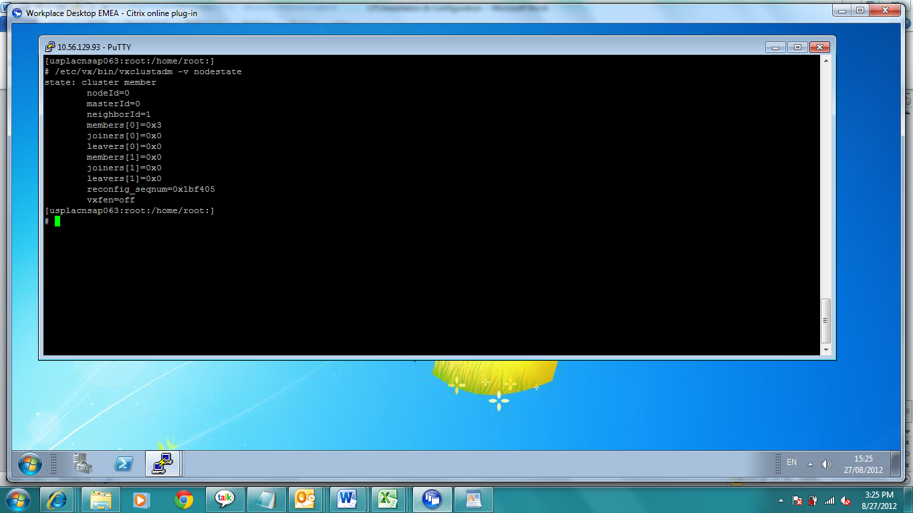
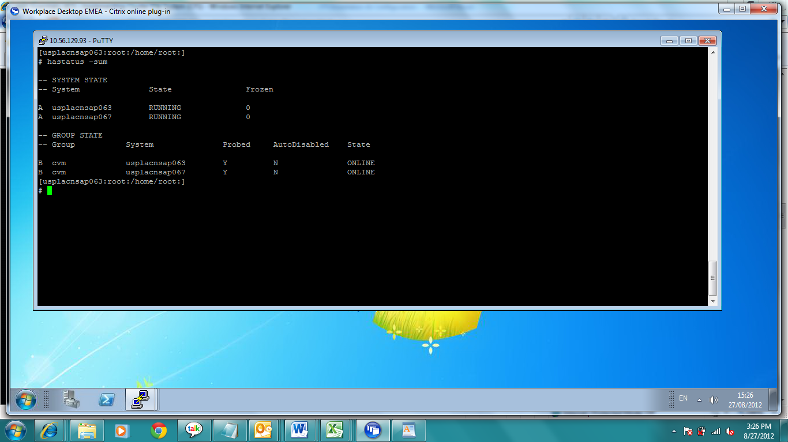
Creating a Shared Disk Group and Volumes/Filesystems
This procedure creates a shared disk group for use in a cluster environment. Disks must be placed in disk groups before they can be used by the Volume Manager.
When you place a disk under Volume Manager control, the disk is initialized. Initialization destroys any existing data on the disk.
Before you begin, make sure the disks that you add to the shared-disk group must be directly attached to all the cluster nodes.
First, make sure you are on the master node:
Initialize the disks you want to use. Make sure they are attached to all the cluster nodes. You may optionally specify the disk format.
Create a shared disk group with the disks you just initialized.
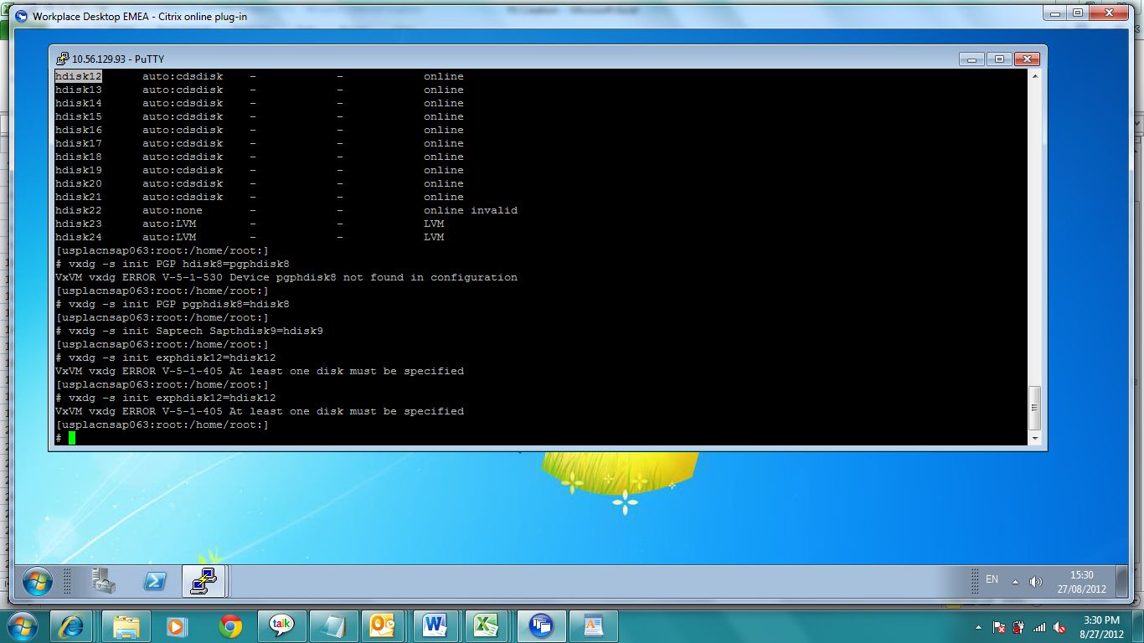
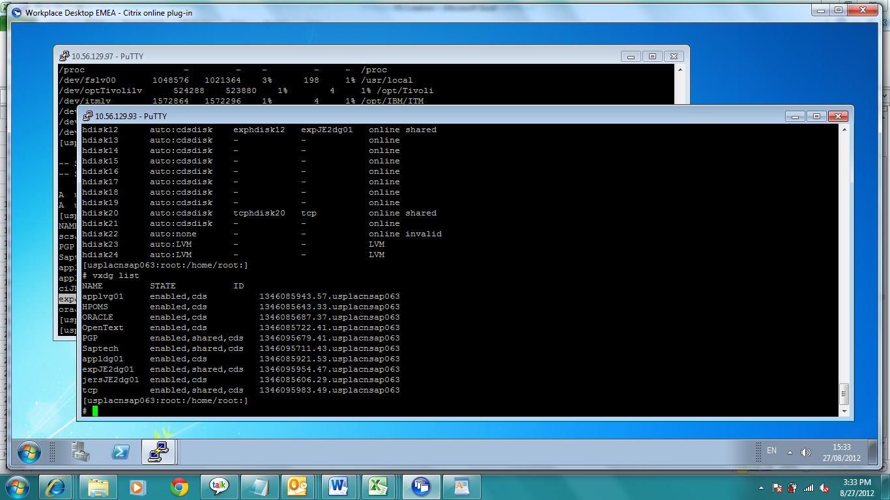

Now let's add that new disk group in our cluster configuration. Giving all nodes in the cluster an option for Shared Write (sw).
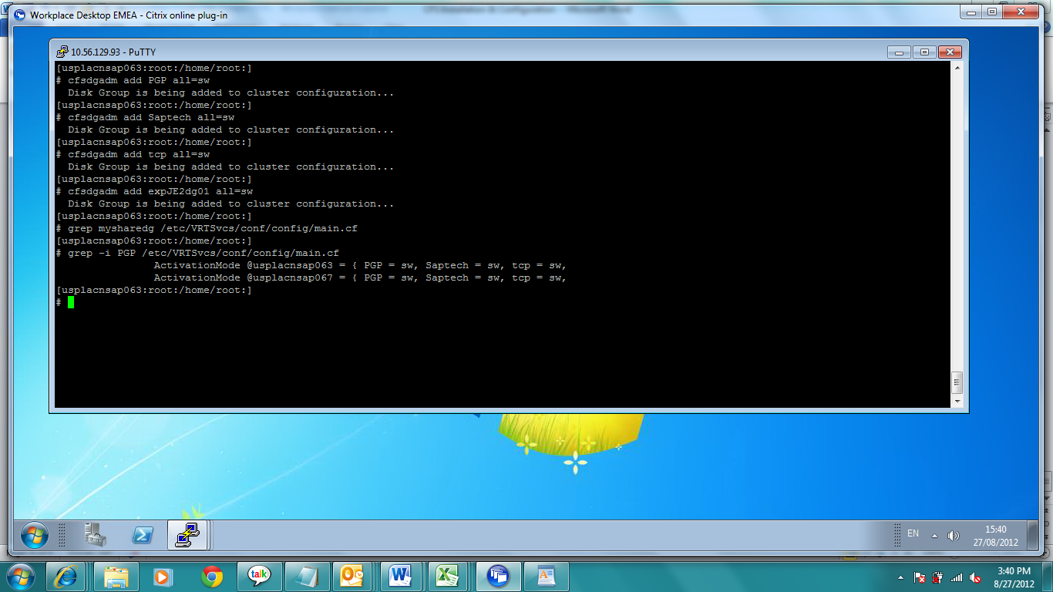
Verify that the cluster configuration has been updated.
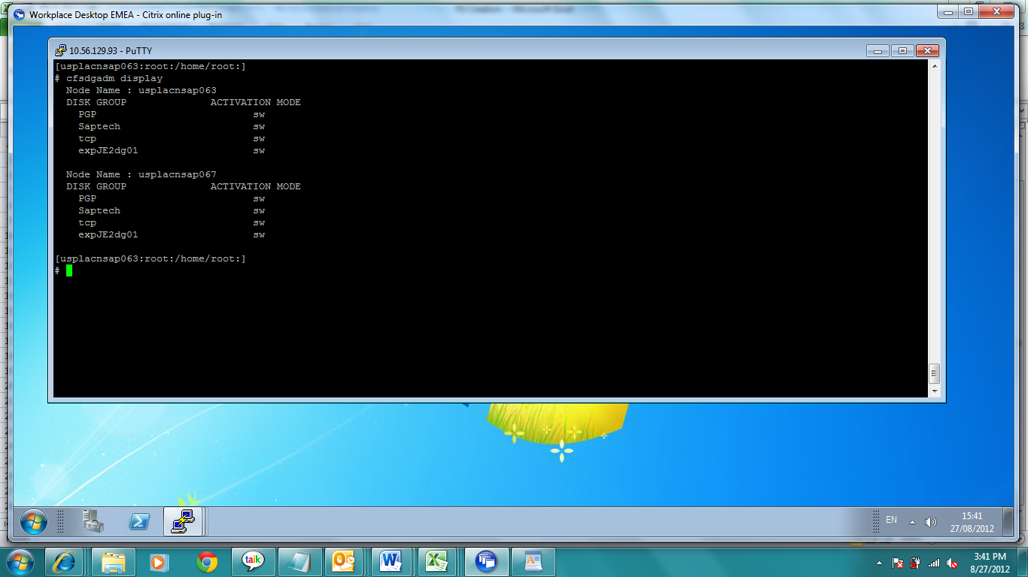
We can now create volumes and filesystems within the shared diskgroup.
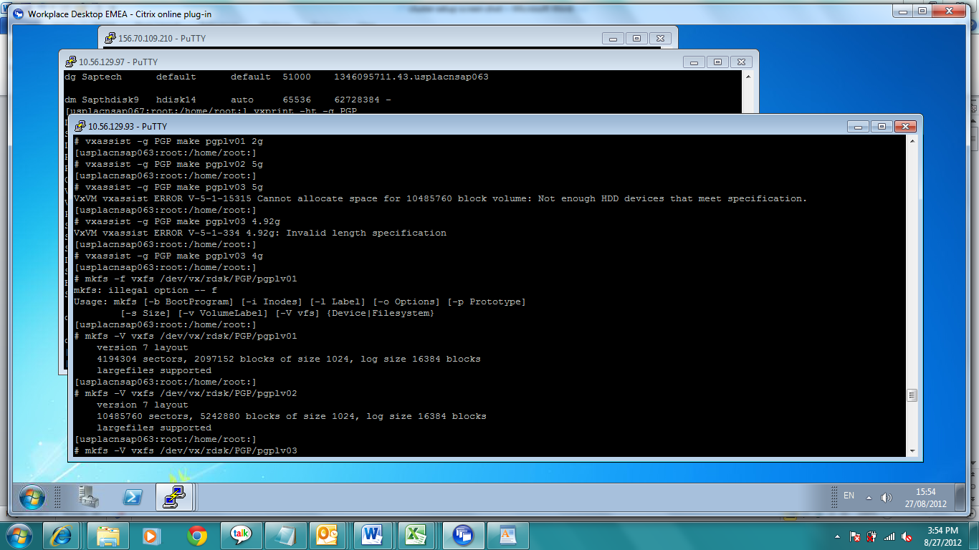

Then add these volumes/filesystems to the cluster configuration so they can be mounted on any or all nodes. Mountpoints will be automatically created

